UNITED STATES

SECURITIES AND EXCHANGE COMMISSION

WASHINGTON, D.C. 20549

FORM 8-K

CURRENT REPORT

Pursuant to Section 13 or 15(d) of the Securities Exchange Act of 1934

Date of Report (Date of earliest event reported): November 4, 2020

CRISPR THERAPEUTICS AG

(Exact name of Registrant as Specified in Its Charter)

Switzerland | 001-37923 | Not Applicable
(State or Other Jurisdiction |  | (IRS Employer
of Incorporation) | (Commission File Number) | Identification No.)
Baarerstrasse 14
6300 Zug, Switzerland |  | Not Applicable
(Address of Principal Executive Offices) |  | (Zip Code)

Registrant’s Telephone Number, Including Area Code: +41 (0)41 561 32 77

Not Applicable

(Former Name or Former Address, if Changed Since Last Report)

Check the appropriate box below if the Form 8-K filing is intended to simultaneously satisfy the filing obligation of the registrant under any of the following provisions (see General Instructions A.2. below):

- Written communications pursuant to Rule 425 under the Securities Act (17 CFR 230.425)

- Soliciting material pursuant to Rule 14a-12 under the Exchange Act (17 CFR 240.14a-12)

- Pre-commencement communications pursuant to Rule 14d-2(b) under the Exchange Act (17 CFR 240.14d-2(b))

- Pre-commencement communications pursuant to Rule 13e-4(c) under the Exchange Act (17 CFR 240.13e-4(c))

Securities registered pursuant to Section 12(b) of the Act:

Title of each class |  | Trading Symbol(s) |  | Name of each exchange on which registered
Common Shares, nominal value CHF 0.03 |  | CRSP |  | The NASDAQ Global Market

Indicate by check mark whether the registrant is an emerging growth company as defined in Rule 405 of the Securities Act of 1933 (§ 230.405 of this chapter) or Rule 12b-2 of the Securities Exchange Act of 1934 (§ 240.12b-2 of this chapter).

Emerging growth company ☐

If an emerging growth company, indicate by check mark if the registrant has elected not to use the extended transition period for complying with any new or revised financial accounting standards provided pursuant to Section 13(a) of the Exchange Act. ☐

Item 7.01. Regulation FD Disclosure.

On November 4, 2020, CRISPR Therapeutics AG, or the Company, issued a press release announcing that a new expanded data set from two ongoing Phase 1/2 clinical trials of the investigational CRISPR/Cas9 gene-editing therapy CTX001TM in severe hemoglobinopathies has been accepted for an oral presentation during the Plenary Scientific Session at the 62nd American Society of Hematology (ASH) Meeting and Exposition, which will take place virtually from December 5-8, 2020. A copy of the press release is attached hereto as Exhibit 99.1.

The information in this Item 7.01 of Form 8-K, including the accompanying Exhibit 99.1, shall not be deemed “filed” for purposes of Section 18 of the Securities Exchange Act of 1934 (the “Exchange Act”), or otherwise subject to the liability of such section, nor shall such information be deemed incorporated by reference in any filing under the Securities Act of 1933 or the Exchange Act, regardless of the general incorporation language of such filing, except as shall be expressly set forth by specific reference in such filing.

Item 8.01. Other Events

On November 4, 2020, ASH published online an abstract submitted by the Company and its partner, Vertex Pharmaceuticals Incorporated, that includes new clinical data from two ongoing Phase 1/2 open-label clinical trials of CTX001 in transfusion-dependent beta thalassemia, or TDT, (CLIMB THAL-

- and severe sickle cell disease, or SCD, (CLIMB SCD-121). Available safety and efficacy results from all patients with at least three months of follow-up from both studies as of July 2020 are presented.

Data are presented for five patients with TDT. These patients had a red blood cell transfusion history ranging from 23.5 to 61 units per year. CTX001 post-infusion follow-up data are presented through months 15, 6, 4, 4, and 3, respectively. In the patients with TDT, median neutrophil engraftment occurred on Day 32 (range: 27 to 36) and median platelet engraftment occurred on Day 37 (range: 34 to 52). All patients demonstrated increases in total hemoglobin, or Hb, and fetal hemoglobin, or HbF, over time. Patients with TDT ceased receiving packed red blood cell, or pRBC, transfusions soon after CTX001 infusion, with the last pRBC transfusion occurring between 0.9 and 1.9 months after CTX001 infusion. See Figure A below.

Data are presented for two patients with SCD. These patients had 7 vaso-occlusive crises, or VOCs, per year and 7.5 VOCs per year, respectively, annualized over two years prior to consent. CTX001 post-infusion follow-up data are presented through months 12 and 3, respectively. In the patients with SCD, neutrophil engraftment occurred on Day 30 and Day 22 and platelet engraftment occurred on Day 30 and Day 33, respectively. All patients demonstrated increases in total Hb and HbF over time. Patients with SCD have had no VOCs since CTX001 infusion. See Figure B below.

In all seven patients, the safety profile after CTX001 infusion was generally consistent with busulfan myeloablation. Four serious adverse events, or SAEs, related or possibly related to CTX001 were reported in one patient with TDT: headache, haemophagocytic lymphohistiocytosis, or HLH, acute respiratory distress syndrome, and idiopathic pneumonia syndrome. All four of these SAEs occurred in the context of HLH and were either resolved or clinically improving at the time of this analysis. No other CTX001-related SAEs were reported in the other patients with TDT or in any patients with SCD.

These trials are ongoing and patients will be followed for approximately two years following infusion.

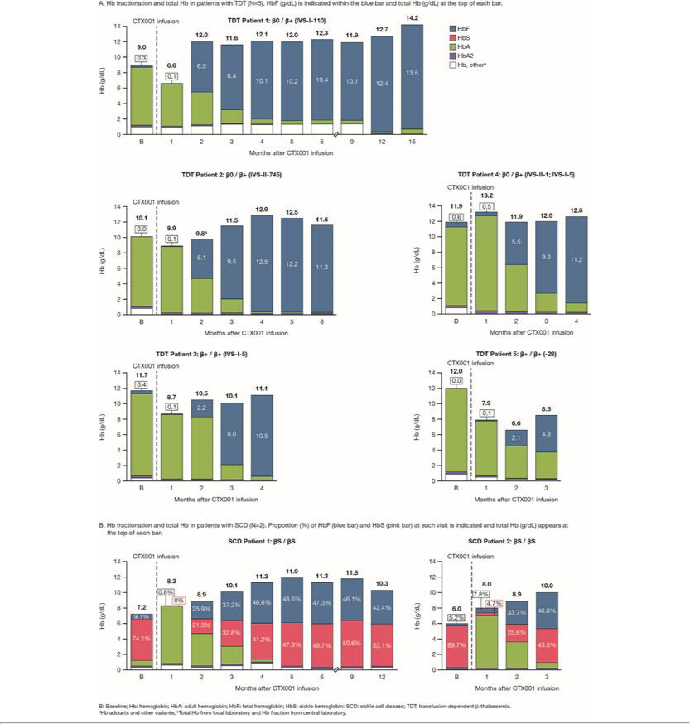

Item 9.01 Financial Statements and Exhibits

(d) Exhibits

Exhibit
Number | Description
99.1 | Press release issued by CRISPR Therapeutics AG, dated November 4, 2020
104 | Cover Page Interactive Data File (embedded within the Inline XBRL document)

SIGNATURES

Pursuant to the requirements of the Securities Exchange Act of 1934, the registrant has duly caused this report to be signed on its behalf by the undersigned hereunto duly authorized.

CRISPR THERAPEUTICS AG

Date: November 4, 2020 By: /s/ Samarth Kulkarni

Samarth Kulkarni, Ph.D.

Chief Executive Officer

Exhibit 99.1

CRISPR/Cas9 Gene-Editing Therapy CTX001™ for Severe Hemoglobinopathies Accepted for Plenary Presentation at the 62nd American Society of Hematology (ASH) Meeting and Exposition

ZUG, Switzerland and CAMBRIDGE, Mass. and BOSTON, November 4, 2020 -- CRISPR Therapeutics (Nasdaq: CRSP) and Vertex Pharmaceuticals Incorporated (Nasdaq: VRTX) today announced data in seven patients from two ongoing Phase 1/2 clinical trials of the investigational CRISPR/Cas9 gene-editing therapy CTX001 in severe hemoglobinopathies has been accepted for an oral presentation during the Plenary Scientific Session at the annual ASH Meeting and Exposition, which will take place virtually from December 5-8, 2020. Haydar Frangoul, M.D., Medical Director of Pediatric Hematology and Oncology at Sarah Cannon Research Institute, HCA Healthcare’s TriStar Centennial Medical Center, will deliver the presentation on behalf of all the authors on December 6, 2020.

An abstract posted online today includes data from five patients with three months to 15 months of follow-up after CTX001 infusion in the ongoing Phase 1/2 CLIMB-111 trial in transfusion-dependent beta thalassemia (TDT) and data from two patients with three months and 12 months of follow-up in the ongoing Phase 1/2 CLIMB-121 trial in severe sickle cell disease (SCD). Additional data will be presented at ASH, including longer-duration follow-up data for the patients included in the abstract and data for additional patients with greater than three months of follow-up.

CTX001 is being investigated in these two ongoing clinical trials as a potential one-time curative therapy for patients suffering from TDT and severe SCD.

The accepted abstract is now available on the ASH conference website.

About CTX001

CTX001 is an investigational, autologous, ex vivo CRISPR/Cas9 gene-edited therapy that is being evaluated for patients suffering from TDT or severe SCD, in which a patient’s hematopoietic stem cells are engineered to produce high levels of fetal hemoglobin (HbF; hemoglobin F) in red blood cells. HbF is a form of the oxygen-carrying hemoglobin that is naturally present at birth, which then switches to the adult form of hemoglobin. The elevation of HbF by CTX001 has the potential to alleviate transfusion requirements for TDT patients and reduce painful and debilitating sickle crises for SCD patients.

Based on progress in this program to date, CTX001 has been granted Regenerative Medicine Advanced Therapy (RMAT), Fast Track, Orphan Drug, and Rare Pediatric Disease designations from the U.S. Food and Drug Administration (FDA). CTX001 has also been granted Orphan Drug Designation from the European Commission for both TDT and SCD, as well as Priority Medicines (PRIME) designation from the European Medicines Agency (EMA) for SCD.

CTX001 is being developed under a co-development and co-commercialization agreement between CRISPR Therapeutics and Vertex. Among gene-editing approaches being investigated/evaluated for TDT and SCD, CTX001 is the furthest advanced in clinical development.

About CLIMB-111

The ongoing Phase 1/2 open-label trial, CLIMB-Thal-111, is designed to assess the safety and efficacy of a single dose of CTX001 in patients ages 12 to 35 with TDT. The trial will enroll up to 45 patients and follow patients for approximately two years after infusion. Each patient will be asked to participate in a long-term follow-up trial.

About CLIMB-121

The ongoing Phase 1/2 open-label trial, CLIMB-SCD-121, is designed to assess the safety and efficacy of a single dose of CTX001 in patients ages 12 to 35 with severe SCD. The trial will enroll up to 45 patients and follow patients for approximately two years after infusion. Each patient will be asked to participate in a long-term follow-up trial.

About the Gene-Editing Process in These Trials

Patients who enroll in these trials will have their own hematopoietic stem and progenitor cells collected from peripheral blood. The patient’s cells will be edited using the CRISPR/Cas9 technology. The edited cells, CTX001, will then be infused back into the patient as part of a stem cell transplant, a process which involves, among other things, a patient being treated with myeloablative busulfan conditioning. Patients undergoing stem cell transplants may also encounter side effects (ranging from mild to severe) that are unrelated to the administration of CTX001. Patients will initially be monitored to determine when the edited cells begin to produce mature blood cells, a process known as engraftment. After engraftment, patients will continue to be monitored to track the impact of CTX001 on multiple measures of disease and for safety.

About the CRISPR-Vertex Collaboration

CRISPR Therapeutics and Vertex entered into a strategic research collaboration in 2015 focused on the use of CRISPR/Cas9 to discover and develop potential new treatments aimed at the underlying genetic causes of human disease. CTX001 represents the first potential treatment to emerge from the joint research program. CRISPR Therapeutics and Vertex will jointly develop and commercialize CTX001 and equally share all research and development costs and profits worldwide.

About CRISPR Therapeutics

CRISPR Therapeutics is a leading gene editing company focused on developing transformative gene-based medicines for serious diseases using its proprietary CRISPR/Cas9 platform. CRISPR/Cas9 is a revolutionary gene editing technology that allows for precise, directed changes to genomic DNA. CRISPR Therapeutics has established a portfolio of therapeutic programs across a broad range of disease areas including hemoglobinopathies, oncology, regenerative medicine and rare diseases. To accelerate and expand its efforts, CRISPR Therapeutics has established strategic collaborations with leading companies including Bayer, Vertex Pharmaceuticals and ViaCyte, Inc. CRISPR Therapeutics AG is headquartered in Zug, Switzerland, with its wholly-owned U.S. subsidiary, CRISPR Therapeutics, Inc., and R&D operations based in Cambridge, Massachusetts, and business offices in San Francisco, California and London, United Kingdom. For more information, please visit www.crisprtx.com.

CRISPR Therapeutics Forward-Looking Statement

This press release may contain a number of “forward-looking statements” within the meaning of the Private Securities Litigation Reform Act of 1995, as amended, as well as statements regarding CRISPR Therapeutics’ expectations about any or all of the following: (i) the status of clinical trials (including, without limitation, the expected timing of data releases) related to product candidates under development by CRISPR Therapeutics and its collaborators, including expectations regarding the data and plans to present data at the annual ASH meeting and exposition; (ii) the expected benefits of CRISPR Therapeutics’ collaborations; and

- the therapeutic value, development, and commercial potential of CRISPR/Cas9 gene editing technologies and therapies. Without limiting the foregoing, the words “believes,” “anticipates,” “plans,” “expects” and similar expressions are intended to identify forward-looking statements. You are cautioned that forward-looking statements are inherently uncertain. Although CRISPR Therapeutics believes that such statements are based on reasonable assumptions within the bounds of its knowledge of its business and operations, forward-looking statements are neither promises nor guarantees and they are necessarily subject to a high degree of uncertainty and risk. Actual performance and results may differ materially from those projected or suggested in the forward-looking statements due to various risks and uncertainties. These risks and uncertainties include, among others: the potential for initial and preliminary data from any clinical trial and initial data from a limited number of patients (as is the case with CTX001 at this time) not to be indicative of final trial results; the potential that CTX001 clinical trial results may not be favorable; the potential impacts due to the coronavirus pandemic, such as the timing and progress of clinical trials; that future competitive or other market factors may adversely affect the commercial potential for CTX001; uncertainties regarding the intellectual property protection for CRISPR Therapeutics’ technology and intellectual property belonging to third parties, and the outcome of proceedings (such as an interference, an opposition or a similar proceeding) involving all or any portion of such intellectual property; and those risks and uncertainties described under the heading "Risk Factors" in CRISPR Therapeutics’ most recent annual report on Form 10-K, quarterly report on Form 10-Q, and in any other subsequent filings made by CRISPR Therapeutics with the U.S. Securities and Exchange Commission, which are available on the SEC's website at www.sec.gov. Existing and prospective investors are cautioned not to place undue reliance on these forward-looking statements, which speak only as of the date they are made. CRISPR Therapeutics disclaims any obligation or undertaking to update or revise any forward-looking statements contained in this press release, other than to the extent required by law.

CRISPR THERAPEUTICS® word mark and design logo and CTX001™ are trademarks and registered trademarks of CRISPR Therapeutics AG. All other trademarks and registered trademarks are the property of their respective owners.

About Vertex

Vertex is a global biotechnology company that invests in scientific innovation to create transformative medicines for people with serious diseases. The company has multiple approved medicines that treat the underlying cause of cystic fibrosis (CF) — a rare, life-threatening genetic disease — and has several ongoing clinical and research programs in CF. Beyond CF, Vertex has a robust pipeline of investigational small molecule medicines in other serious diseases where it has deep insight into causal human biology, including pain, alpha-1 antitrypsin deficiency and APOL1-mediated kidney diseases. In addition, Vertex has a rapidly expanding pipeline of genetic and cell therapies for diseases such as sickle cell disease, beta thalassemia, Duchenne muscular

dystrophy and type 1 diabetes mellitus.

Founded in 1989 in Cambridge, Mass., Vertex's global headquarters is now located in Boston's Innovation District and its international headquarters is in London. Additionally, the company has research and development sites and commercial offices in North America, Europe, Australia and Latin America. Vertex is consistently recognized as one of the industry's top places to work, including 11 consecutive years on Science magazine's Top Employers list and a best place to work for LGBTQ equality by the Human Rights Campaign. For company updates and to learn more about Vertex's history of innovation, visit www.vrtx.com or follow us on Facebook, Twitter, LinkedIn, YouTube and Instagram.

Vertex Special Note Regarding Forward-Looking Statements

This press release contains forward-looking statements as defined in the Private Securities Litigation Reform Act of 1995, including, without limitation, statements regarding the expectations and plans to present data at the annual ASH meeting and exposition, the development, including expected timeline for development, and potential benefits of CTX001, our plans and expectations for our clinical trials and clinical trial sites, and the status of our clinical trials of our product candidates under development by us and our collaborators, including activities at the clinical trial sites and potential outcomes. While Vertex believes the forward-looking statements contained in this press release are accurate, these forward-looking statements represent the company's beliefs only as of the date of this press release and there are a number of risks and uncertainties that could cause actual events or results to differ materially from those expressed or implied by such forward-looking statements. Those risks and uncertainties include, among other things, that data from the company's development programs, including its programs with its collaborators, may not support registration or further development of its compounds due to safety, efficacy or other reasons, and other risks listed under Risk Factors in Vertex's most recent annual report and subsequent quarterly reports filed with the Securities and Exchange Commission and available through the company's website at www.vrtx.com. You should not place undue reliance on these statements or the scientific data presented. Vertex disclaims any obligation to update the information contained in this press release as new information becomes available.

(VRTX-GEN)

CRISPR Therapeutics Investor Contact:

Susan Kim, +1 617-307-7503
susan.kim@crisprtx.com

CRISPR Therapeutics Media Contact:

Rachel Eides
WCG on behalf of CRISPR
+1 617-337-4167
reides@wcgworld.com

Vertex Pharmaceuticals Incorporated

Investors:
Michael Partridge, +1 617-341-6108

or

Zach Barber, +1 617-341-6470
or

Brenda Eustace, +1 617-341-6187

Media:

mediainfo@vrtx.com
or
U.S.: +1 617-341-6992
or

Heather Nichols: +1 617-839-3607
or

International: +44 20 3204 5275

